TESTING ANGULAR2 overview -

UNIT TEST case

FAKING AND SET UP OF DEPENDENCIES

Fake Service

Jasmine spy

Spies vs Faking

Fake Code

Jasmine spy code

Types of Unit Test

Shallow tests to test HTML template

TESTBED API for shallow tests -

TestBed Api Code

E2E tests

E2E Test code

Async vs Fake Async

ASYNC code extract

Fake Async code exract

Async code

Async vs fake Async difference

##### **TESTING ANGULAR2 overview -**

We write test using BDD,IT USES JASMINE , KARMA, protract

BDD WRITING STYLE (JASMINE) **spec or it** test , we can have multiple describe blocks inside describe

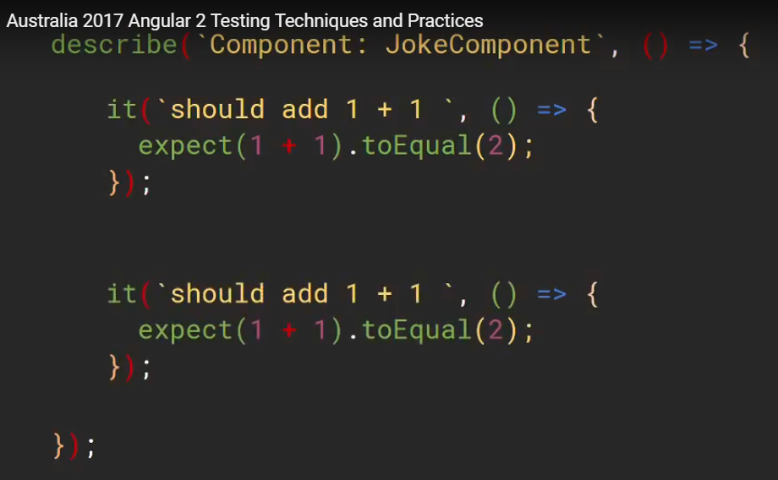

WALLBY JS - gives live feedback of test, executes faster

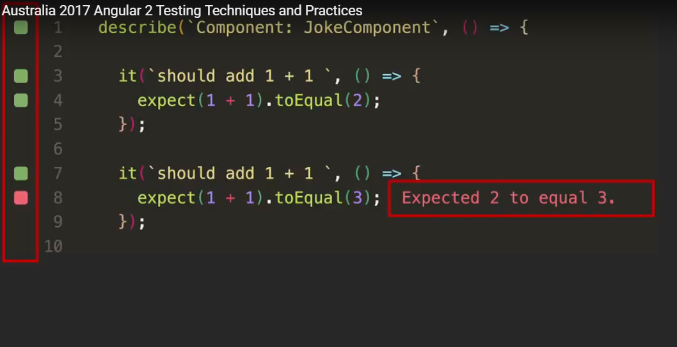

By using Angular CLI testing harness is already set up

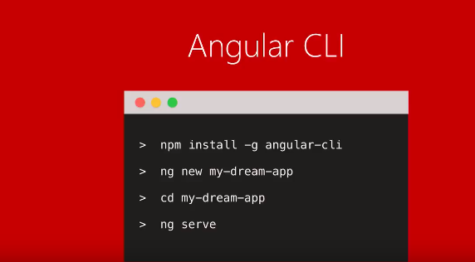

##### UNIT TEST case

We have a component on button click

Component talks to angular service, means we have dependency on that service in component,which we need to mock, service calls backend so we need to make http request, and we need to receive response and put back in DOM or HTML template

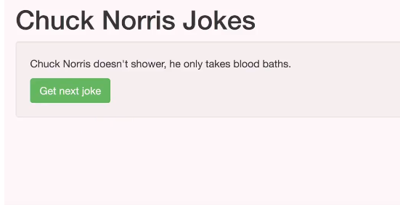

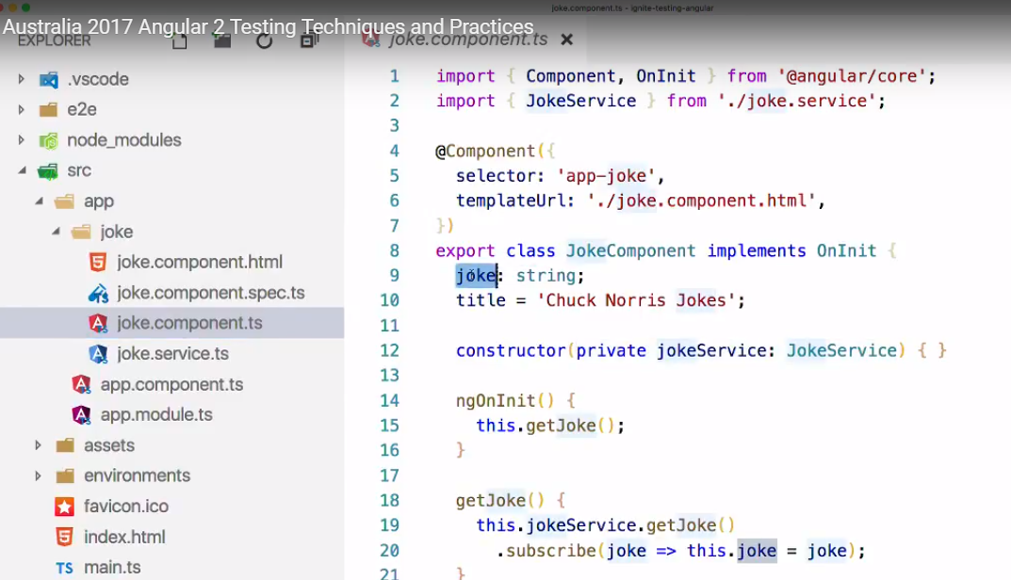

**Ng-test** kicks off karma, karma will build our app and watch for any file changes and reruns test as we go

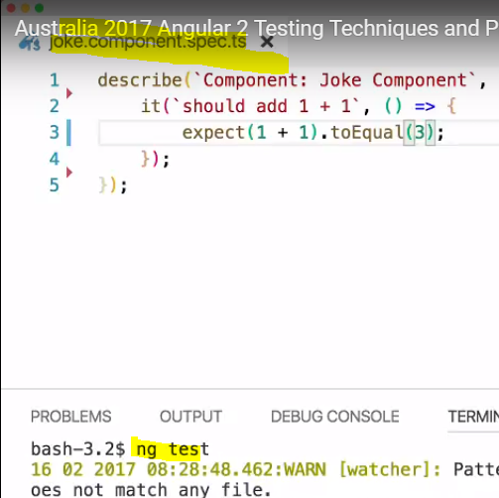

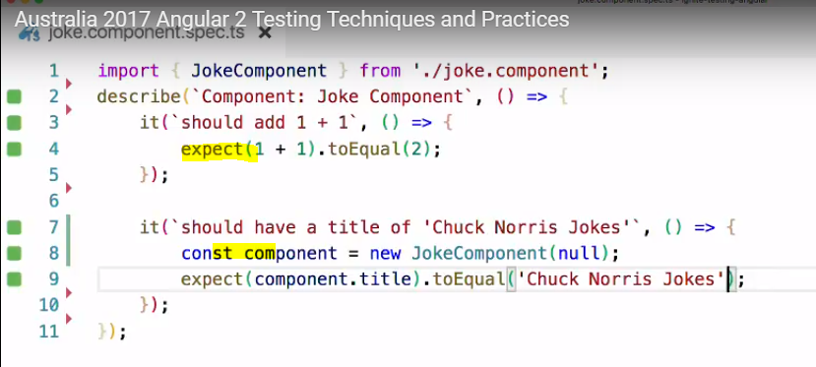

##### FAKING AND SET UP OF DEPENDENCIES

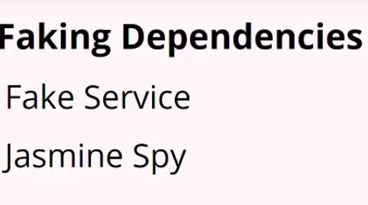

###### Fake Service

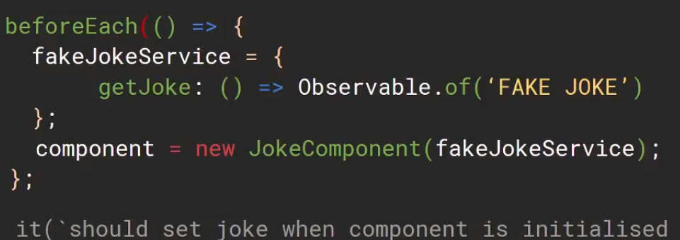

###### Jasmine spy

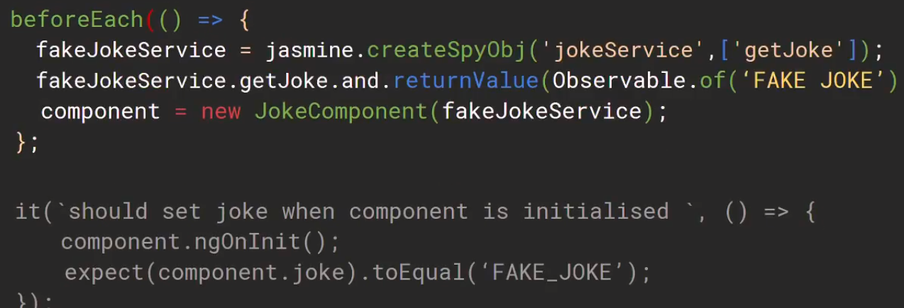

##### Spies vs Faking

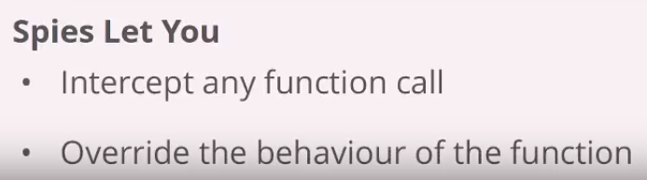

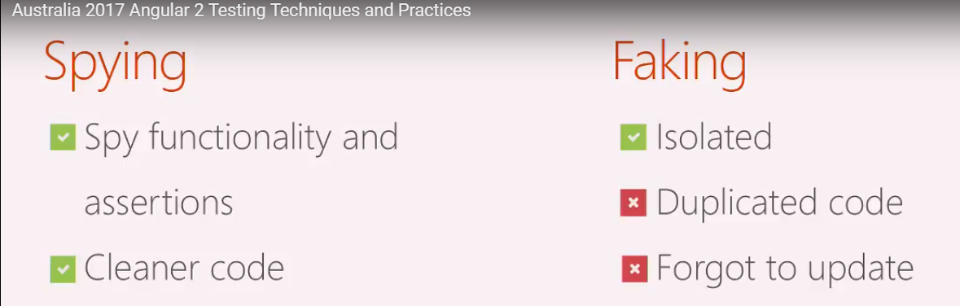

**If we have 20 tests , we cant create instance of component each time so as below to keep code DRY**

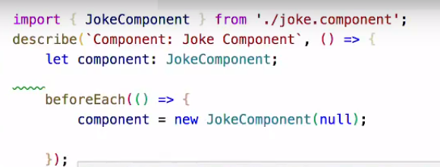

##### Fake Code

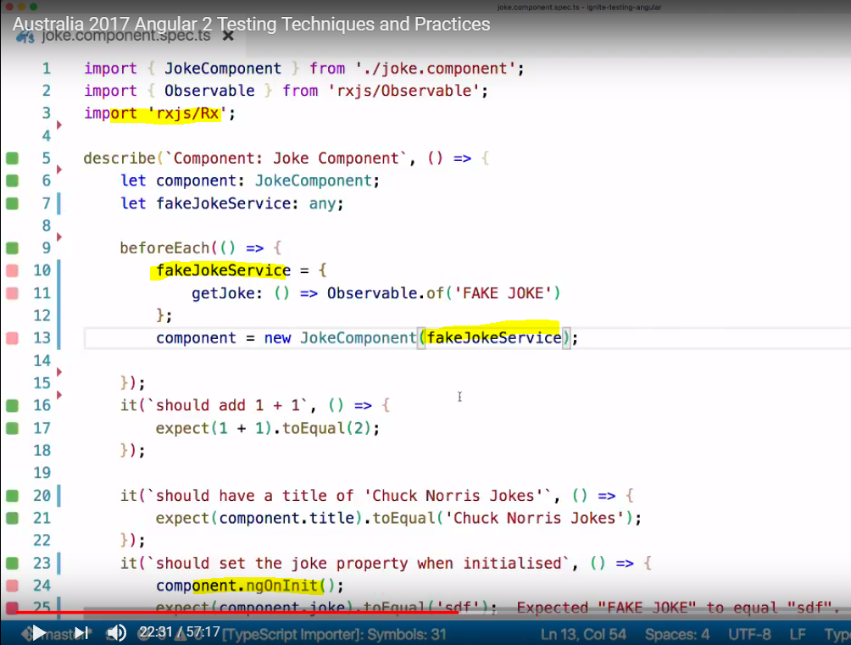

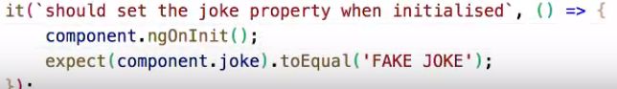

##### Jasmine spy code

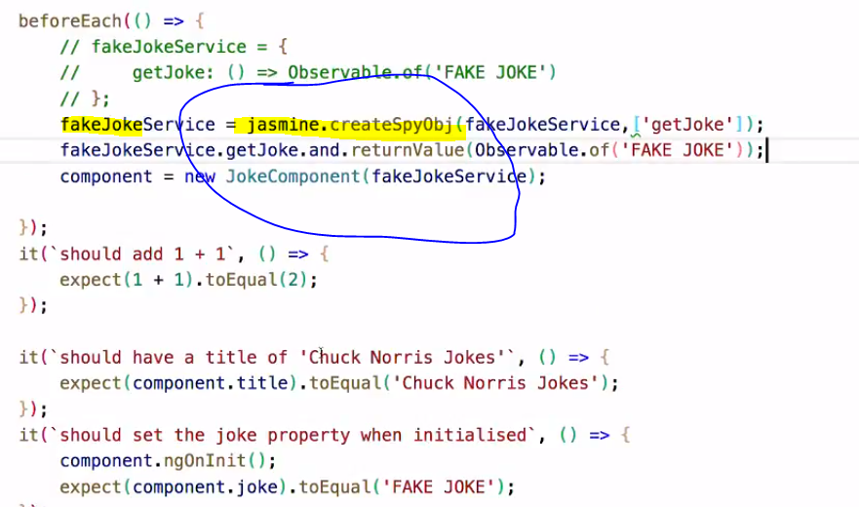

##### Types of Unit Test

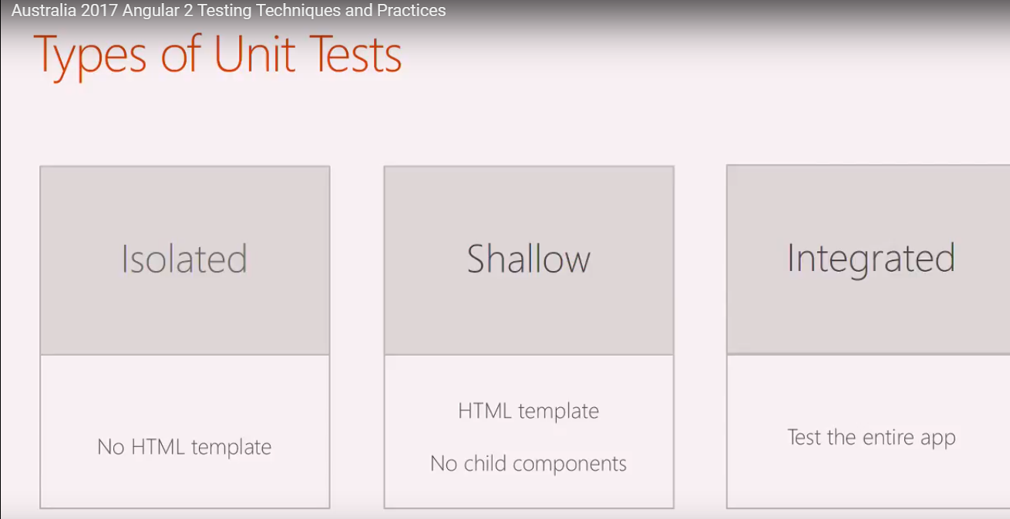

##### Shallow tests to test HTML template

**Ng module tells that for this section of code,these are the dependencies,it** happens same like in test module

##### TESTBED API for shallow tests -

IT SAYS THAT FOR THIS TEST SUITE TO RUN, the below are dependencies we have and thru testbed we get hold of fixture

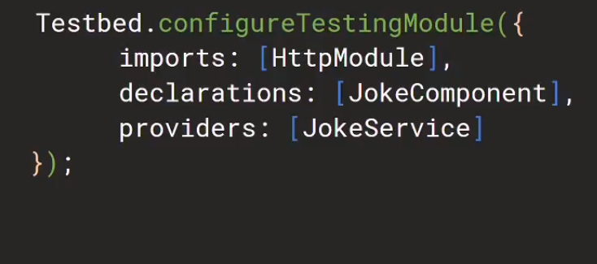

Component instance, we get class, properties, methods

Debug element allow us to debug element query and query html template

Detect changes - fixture can u please detect changes as i have changed html template

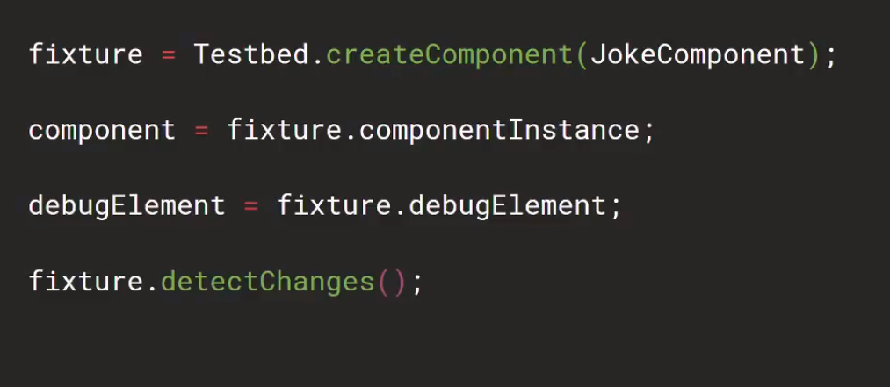



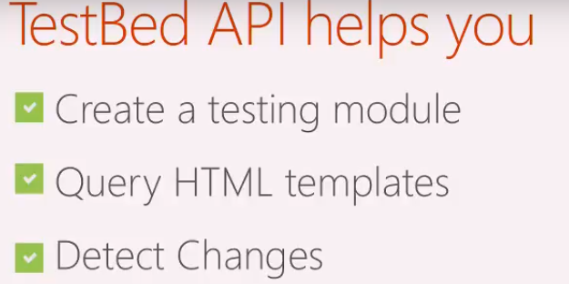

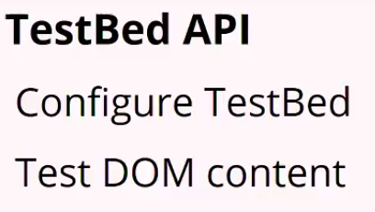

##### TestBed Api Code

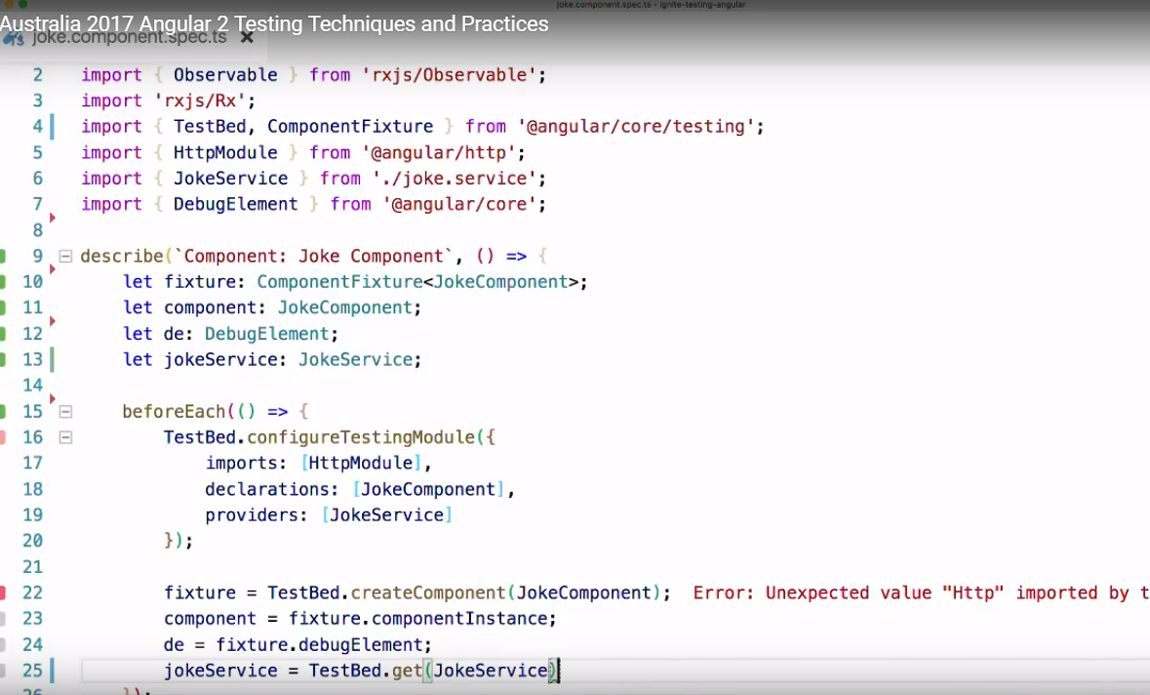

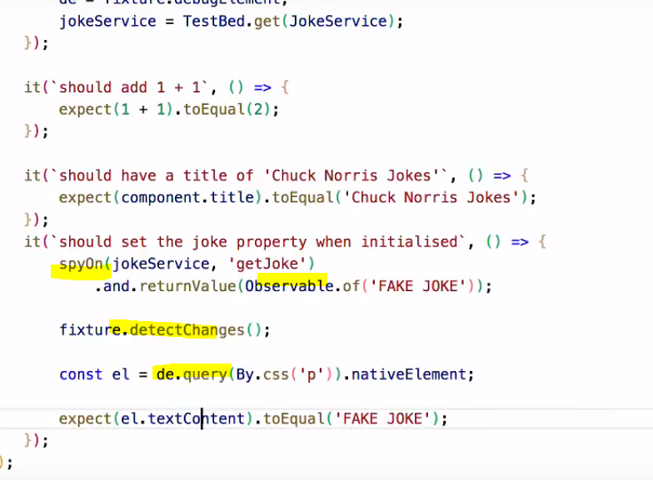

##### E2E tests

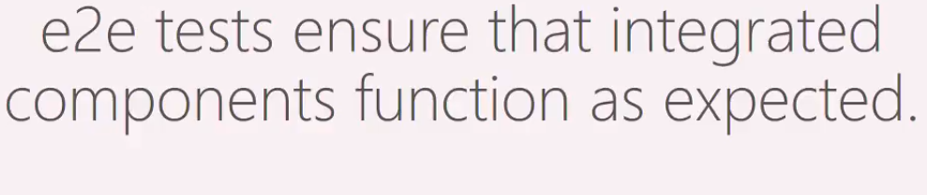

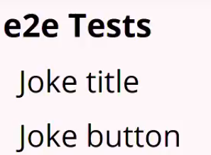

##### E2E Test code

**Browser** - allows to navigate between pages, **element,by**,are helpers to select dom

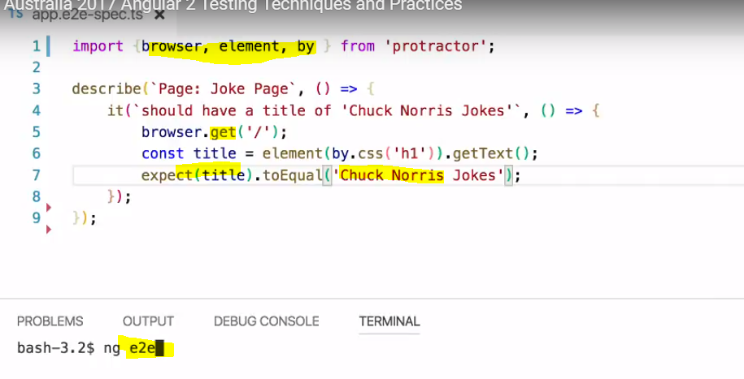

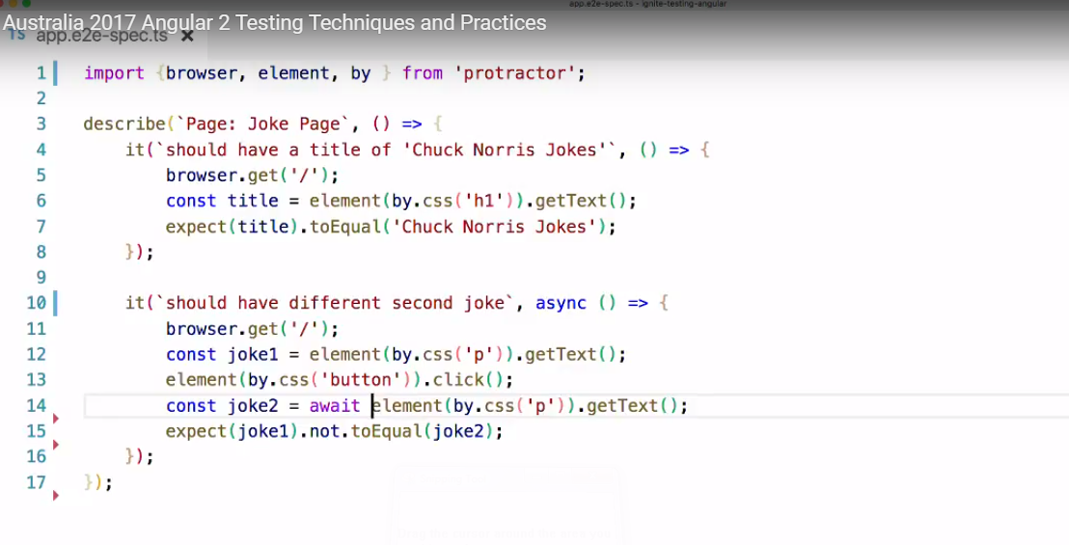

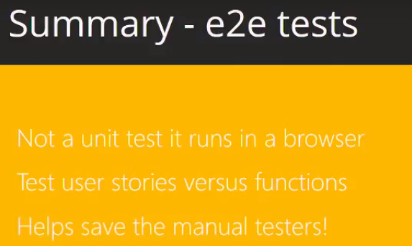

##### Async vs Fake Async

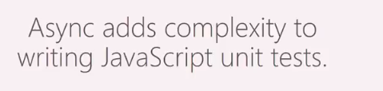Async happens everywhere, when we click button, it calls service and it takes time to return, which may make writing tests complex

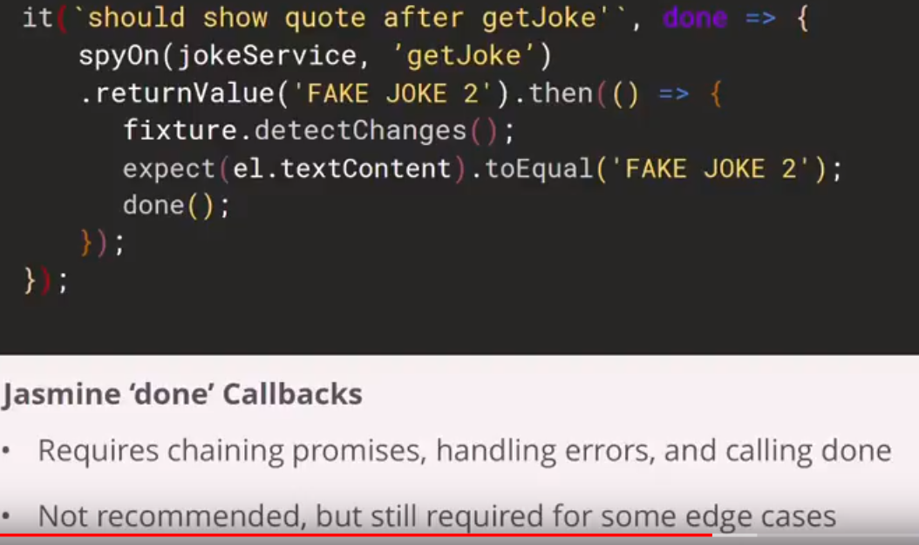

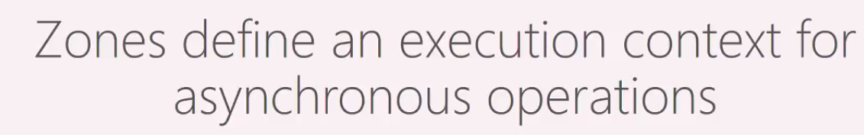

When we do any async operation or writing components, if we call service service has to return request, or data binding, there is a queue and everytime async opr is put on micro task queue and when queue gets down to 0, the async oprs has completed which is a zone

##### ASYNC code extract

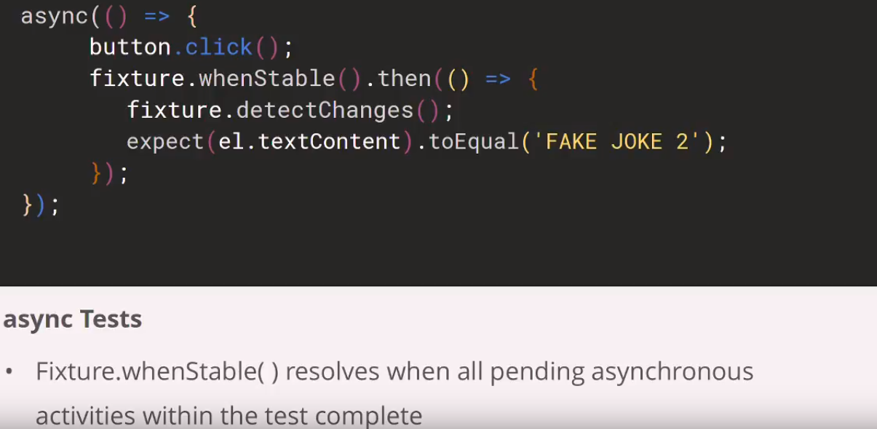

##### Fake Async code exract

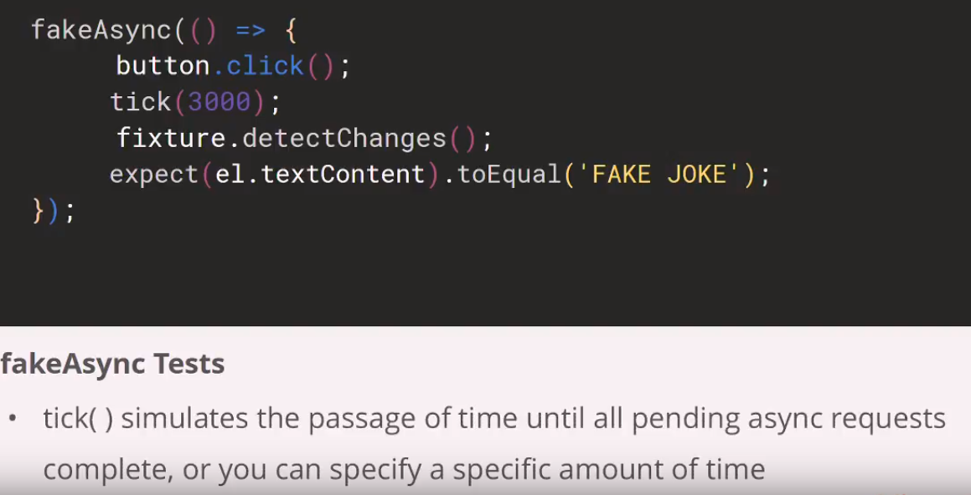

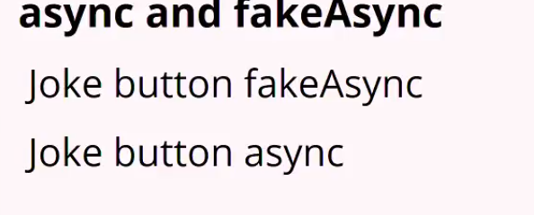

##### Async code

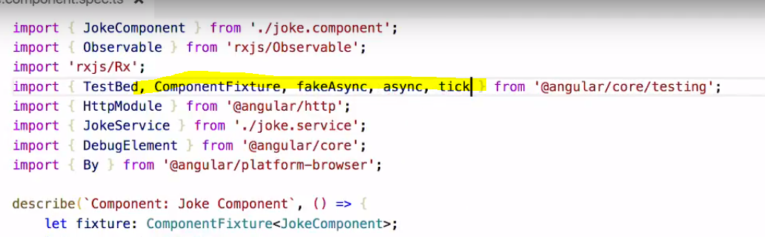

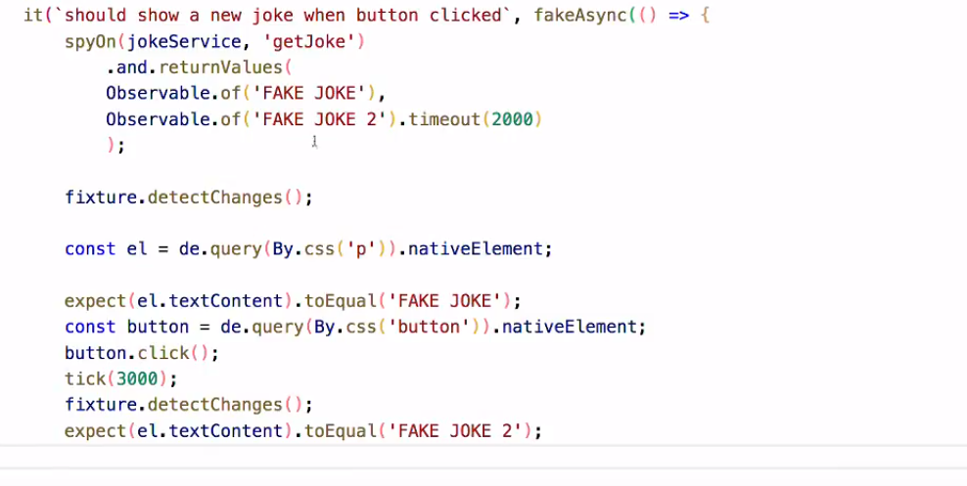

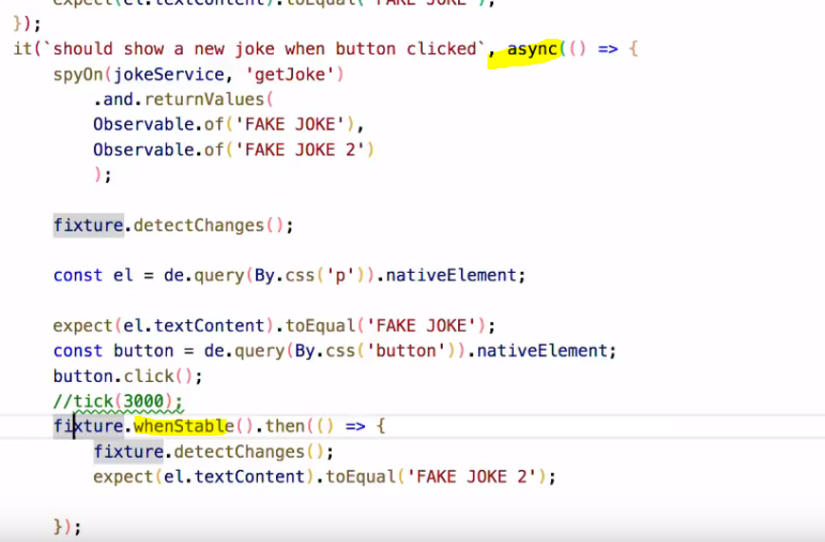

##### Async vs fake Async difference

